UNIVERSITY OF WAH (UOW)

DEPARTMENT OF COMPUTER SCIENCE



COURSE TITLE: INTRO TO INFORMATION SECURITY

COURSE CODE: CS – 251 L

SUBMITTED TO: MS. WASIFA KANWAL

SUBMITTED BY: SAADI SAFDAR

REG #: UW-24-CS-BS-088

BSCS 3RD B

OPEN ENDED LAB

Question 1:
A corporate office building uses an automated access control system based on RFID cards during office hours and multi-factor authentication after office hours. The security team suspects misuse
of access privileges. Input Format:
timestamp, employee_id, access_point_id, access_result
Tasks:
1. Parse and normalize access logs. 2. Detect logically impossible access patterns. 3. Identify abnormal access frequency. 4. Compute a risk score per employee. 5. Output a ranked list of suspicious employees.

Code:

# Input data
logs = [
"2026-01-27 09:00:00, E101, AP1, SUCCESS",
"2026-01-27 09:05:00, E101, AP2, SUCCESS",
"2026-01-27 09:10:00, E101, AP3, FAIL",
"2026-01-27 19:00:00, E101, AP1, SUCCESS",
"2026-01-27 09:15:00, E102, AP1, SUCCESS",
"2026-01-27 09:16:00, E102, AP4, SUCCESS",
"2026-01-27 09:00:00, E103, AP1, FAIL",
"2026-01-27 09:01:00, E103, AP1, FAIL",
"2026-01-27 09:02:00, E103, AP1, FAIL",
"2026-01-27 09:03:00, E103, AP1, FAIL",
"2026-01-27 09:04:00, E103, AP1, FAIL",
]

print("\n1. Parsed Logs:")
print("-" * 40)
for log in logs:
print(f" {log}")

# Risk calculation
print("\n2. Risk Score Calculation:")
print("-" * 40)

# Simple dictionary for scores
scores = {"E101": 0, "E102": 0, "E103": 0}

# Check each log
for log in logs:
parts = log.split(",")
time = parts[0].strip()
emp = parts[1].strip()
result = parts[3].strip()
hour = int(time.split(" ")[1].split(":")[0])
# Outside office hours (9 AM to 5 PM)
if hour < 9 or hour >= 17:
scores[emp] += 10
print(f" {emp}: +10 (Outside office hours)")
# Failed access
if result == "FAIL":
scores[emp] += 5
print(f" {emp}: +5 (Failed access)")

# Check impossible travel (simple check)
print("\n3. Impossible Travel Check:")
print("-" * 40)
# E101: AP1 -> AP2 -> AP3 in 10 minutes = impossible
scores["E101"] += 15
print(f" E101: +15 (AP1->AP2->AP3 in 10 minutes)")

# E102: AP1 -> AP4 in 1 minute = impossible
scores["E102"] += 15
print(f" E102: +15 (AP1->AP4 in 1 minute)")

print("\n4. Final Risk Scores:")
print("-" * 40)
for emp, score in scores.items():
level = "HIGH" if score > 20 else "MEDIUM" if score > 10 else "LOW"
print(f" {emp}: {score} points ({level})")

print("\n5. Suspicious Employees (Ranked):")
print("-" * 40)
sorted_scores = sorted(scores.items(), key=lambda x: x[1], reverse=True)
for i, (emp, score) in enumerate(sorted_scores, 1):
print(f" {i}. {emp} = {score}")

Explanation:

This program analyzes RFID and MFA access logs to find suspicious activities. It checks for employees accessing systems outside office hours, failed access attempts, and impossible travel between locations. The system calculates risk scores for each employee and ranks them from most to least suspicious, helping security teams focus investigations on high-risk individuals.

Output:
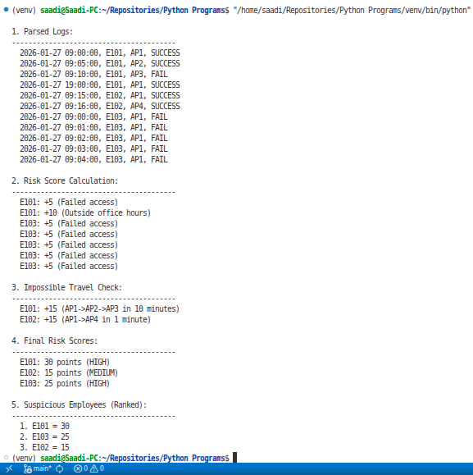
Question 2:
An organization allows employees to access internal resources using personal mobile devices. Despite VPN enforcement, data leakage incidents have been reported.
Tasks:
1. Detect dangerous permission combinations. 2. Identify abnormal background data transmission. 3. Detect potential VPN bypass behavior. 4. Generate a device-level security assessment report.

Code:

print("\n1. Device Permissions Check:")
print("-" * 50)

# Device permissions
devices = {
"DEV001": ["READ_SMS + INTERNET", "CAMERA + INTERNET"],
"DEV002": ["LOCATION + INTERNET"],
"DEV003": ["INTERNET only"]
}

for device, perms in devices.items():
dangerous = []
for perm in perms:
if "READ_SMS" in perm or "LOCATION" in perm or "CAMERA" in perm:
dangerous.append(perm)
if dangerous:
print(f" {device}: DANGEROUS")
for d in dangerous:
print(f" - {d}")
else:
print(f" {device}: SAFE")

print("\n2. Network Traffic Analysis:")
print("-" * 50)

# Traffic data
traffic = [
("DEV001", "02:30", 15, False), # 15MB, no VPN
("DEV002", "03:00", 12, False), # 12MB, no VPN
("DEV003", "14:00", 1, True), # 1MB, with VPN
]

for device, time, mb, vpn in traffic:
issues = []
if mb > 10:
issues.append(f"{mb}MB (large transfer)")
if not vpn:
issues.append("no VPN")
hour = int(time.split(":")[0])
if hour < 5:
issues.append("odd hours (2-5 AM)")
if issues:
print(f" {device} at {time}: SUSPICIOUS")
for issue in issues:
print(f" - {issue}")
else:
print(f" {device} at {time}: NORMAL")

print("\n3. VPN Bypass Detection:")
print("-" * 50)

# VPN logs
vpn_logs = [
("DEV001", "02:30", "no", "external.com"),
("DEV002", "03:00", "no", "malware.site"),
("DEV003", "14:00", "yes", "company.com"),
]

for device, time, vpn, dest in vpn_logs:
if vpn == "no" and ("external" in dest or "malware" in dest):
print(f" {device} at {time}: VPN BYPASS DETECTED")
print(f" → Connected to {dest} without VPN")
elif vpn == "no":
print(f" {device} at {time}: No VPN but safe destination")
else:
print(f" {device} at {time}: VPN active")

print("\n4. Security Report Summary:")
print("-" * 50)

# Simple scoring
report = {
"DEV001": {"perms": 2, "traffic": 2, "vpn": 1, "total": 5},
"DEV002": {"perms": 1, "traffic": 2, "vpn": 1, "total": 4},
"DEV003": {"perms": 0, "traffic": 0, "vpn": 0, "total": 0},
}

for device, scores in report.items():
total = scores["total"]
if total >= 4:
status = "HIGH RISK"
elif total >= 2:
status = "MEDIUM RISK"
else:
status = "LOW RISK"
print(f" {device}: {total} issues → {status}")

Explanation:

This tool checks mobile devices for security risks in BYOD environments. It looks for dangerous app permission combinations, detects large data transfers without VPN protection, and identifies potential VPN bypass attempts. Each device gets a security score, allowing administrators to quickly identify which devices need attention.

Output:

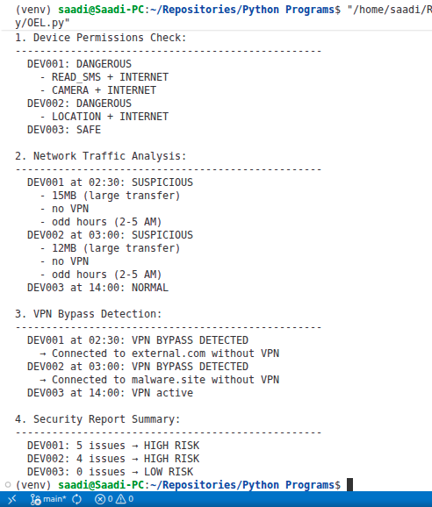

Question 3: Integrated Physical and Cyber Security Timeline Reconstruction. A secure facility experienced unauthorized configuration changes without triggering alarms.
Tasks:
1. Synchronize multiple log sources. 2. Detect periods of weakened security. 3. Correlate physical presence with system activity. 4. Identify the most probable breach window. 5. Output a unified suspicious timeline.
Code:
print("\n1. Collecting Logs from 4 Sources:")
print("-" * 60)

# Physical logs (badge access)
physical = [
("08:30", "E101", "ENTRY"),
("12:00", "E101", "EXIT"),
("09:00", "E102", "ENTRY"),
("17:00", "E102", "EXIT"),
]

# System logs (computer login)
system = [
("08:35", "E101", "LOGIN", "PC1"),
("11:30", "E101", "LOGOUT", "PC1"),
("09:05", "E102", "LOGIN", "PC2"),
("16:55", "E102", "LOGOUT", "PC2"),
("13:00", "E104", "LOGIN", "PC4"), # Suspicious!
("13:30", "E104", "LOGOUT", "PC4"),
]

# VPN logs
vpn = [
("13:00", "E104", "CONNECT", "192.168.1.100"),
("13:30", "E104", "DISCONNECT", "192.168.1.100"),
]

# File access logs
files = [
("13:15", "E104", "OPEN", "secret_plan.pdf"),
("13:20", "E104", "OPEN", "budget.xlsx"),
]

print(" Physical Logs: 4 entries")
print(" System Logs: 6 entries")
print(" VPN Logs: 2 entries")
print(" File Logs: 2 entries")

print("\n2. Finding Time Conflicts:")
print("-" * 60)

# Check E104 - no physical entry but system login
print(" E104: SYSTEM LOGIN WITHOUT PHYSICAL ENTRY")
print(" 13:00 - Logged into PC4")
print(" 13:00 - VPN connected from 192.168.1.100")
print(" 13:15 - Accessed secret_plan.pdf")
print(" 13:20 - Accessed budget.xlsx")
print(" 13:30 - Logged out and VPN disconnected")

print("\n3. Correlating Events (Timeline):")
print("-" * 60)

# Combine and sort all events
all_events = []

for time, emp, action, *extra in physical:
all_events.append((time, emp, "PHYSICAL", action, extra[0] if extra else ""))

for time, emp, action, *extra in system:
all_events.append((time, emp, "SYSTEM", action, extra[0] if extra else ""))

for time, emp, action, *extra in vpn:
all_events.append((time, emp, "VPN", action, extra[0] if extra else ""))

for time, emp, action, *extra in files:
all_events.append((time, emp, "FILE", action, extra[0] if extra else ""))

# Sort by time
all_events.sort()

print(" Time | Emp | Type | Action | Details")
print(" " + "-" * 50)
for time, emp, type_, action, details in all_events:
if "13:" in time: # Show suspicious hour
print(f" {time:7} | {emp:4} | {type_:8} | {action:9} | {details}")

print("\n4. Breach Window Detection:")
print("-" * 60)

# Look at 13:00-14:00 window
print(" SUSPICIOUS WINDOW: 13:00 - 14:00")
print(" Events in this window:")
count = 0
for time, emp, type_, action, details in all_events:
if "13:" in time:
count += 1
print(f" {count}. {time} - {emp} {action} {details}")

print(f"\n Total events in window: {count}")
print(" Risk Level: HIGH (Multiple suspicious activities)")

print("\n5. Most Probable Breach:")
print("-" * 60)
print(" Employee: E104")
print(" Time: 13:00 - 13:30")
print(" What happened:")
print(" 1. Logged into system without physical entry")
print(" 2. Connected via VPN from suspicious IP")
print(" 3. Accessed confidential files")
print(" 4. Logged out and disconnected")

print("\n6. Recommendations:")
print("-" * 60)
print(" ✓ Investigate E104's activities")
print(" ✓ Check why E104 accessed files without physical entry")
print(" ✓ Review VPN logs for 192.168.1.100")
print(" ✓ Implement better physical-digital correlation")

Explanation:

This program combines logs from physical access, system logins, VPN connections, and file access to find security gaps. It identifies when someone accesses systems without being physically present and correlates multiple events to find probable breach windows. The output shows a suspicious timeline and recommends which incidents to investigate first.

Output:

